Temperature Sensor

Temperature Biofeedback
Blood flow or temperature biofeedback is a primary tool for general relaxation training. The temperature feedback instrument shows when blood flow is increasing by showing an increase in finger temperature. Because blood flow in the hands responds to stress and relaxation the client learns to relax by watching the rise and the fall of temperature. The client becomes aware of internal feelings associated with relaxation and will learn to voluntarily produce this state.

Important Applications

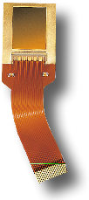
The fingers features can be acquired optically, thermally based on temperature differences between the fingertip's valleys and ridges, by a pressure sensor or via a capacitive sensor which is essentially a small silicon chip with many thousands of sensing elements. For instance Infineon's "FingerTIP sensor uses the capacity difference between the surface of the sensor and the surface of the finger. The capacity measured at a ridge differs from that at a valley. Thus, about 65.000 capacitors acquire the data in a field of 224 x 288 pixels and transform it into a digital signal."
Thermal sensors rely on measuring temperature differences at the fingertip so they can be influenced by changes in temperature in the surrounding environment. Generally thermal sensors must operate in a O° C or above ambient temperature.
Temperature Biofeedback:
This device monitors skin temperature and can be helpful in certain circulatory disorders. Reynolds disease is an example that can be benefited by this technique. Usually, a sensor is attached to your foot or to the middle or small finger of your dominant hand. When you are tense or anxious, your skin temperature drops as blood is redirected inward to muscles and internal organs. Like monitoring muscle tension, measuring skin temperature is a useful tool in learning how to manage stress. This method may also reduce the frequency of migraine headaches, and is also used to promote relaxation.

How do STRESS and Temperature relate
The Stress Computer will let you see to 1/10 of one degree the stress you experience in different situations. Changes in hand/foot temperature are a reflection of blood flow - a measure of the stress response. For example, while talking about an upsetting incident involving your parents, an employer/employee, or friend your temperature may drop 5_ to 20_. In contrast, when recalling a minor misunderstanding your temperature may only drop one degree. And yet, when you recall the warm sun on a recent vacation, your temperature may increase a full 10_.
What is most surprising is how quickly the changes occur. People often comment, I never had any idea that little finger could show so much!
The basic rule for interpreting temperature change is simple, Warmer hands/feet indicate Relaxation while Colder hands/feet reflect Activation or Tension. When the body's fight/ flight system is activated the muscles tense, heart rate and the vital organs speed up. As a result, blood flow is shunted from the extremities and directed to the vital organs to facilitate the increased level of arousal. As a result, changes of 5_, 10 or 15_ can occur within just a few minutes.

Understanding Temperature
Your hand temperature can change from 60_ to 99_ degrees Fahrenheit (15.5_ to 37.2_ Celsius). Keep in mind this general rule: WARM HANDS INDICATE RELAXATION WHILE COLD HANDS REFLECT TENSION. Not everyone reacts to stress through dramatically colder hands and feet. You may also react by tensing muscles like your forehead, jaw, shoulders, etc. Perhaps your stomach has butterflies or becomes upset. Each of us reacts to stress in our own special way. Hand temperature is just one simple and effective way to measure stress levels.
There is no normal temperature but a range over which temperature fluctuates and changes.
Below79 _ 79-84_ 84-90_ 90-95_ Above 95_ (F)
Highly Slightly Mildly Quietly Deeply
Tense Tense Calm Relaxed Relaxed

Below26_ 26-29_ 29-32_ 32-35_ Above 35_(C)
Introduction
Virtually everybody who has had an amputation reports feeling sensations which appear to emanate from the amputated portion of the limb. Most of the time, these "phantom" sensations are painless and of sufficiently low intensity to be no more than a mild distraction(9). The sensations are usually similar to those which would be felt in an intact limb, including warmth, itching, sense of position, and mild squeezing. Awareness of details of the limb's shape and perceived ability to move it tend to fade with time. However, almost all amputees report continuing to feel at least some phantom sensations throughout the remainder of their lives. When phantom sensations become intense enough for the amputee to define them as painful, they are called "phantom pains". The neural mechanisms which permit perception of phantom limbs are well recognized(3,4). Sensations reaching the brain are identified for location on the skin by the homunculus, in the sensory cortex, which contains a representation of the entire body surface. Thus, a pinch of the left index finger tip stimulates a location on the homunculus representing the left index finger tip.
If the finger was amputated and a signal was started by pressure, etc., anywhere along the remaining nerve paths between the finger stump and homunculus, the resulting sensation would seem to emanate from the finger tip because the paths do not change much after amputation and the brain has no way to know that the finger tip is not present.
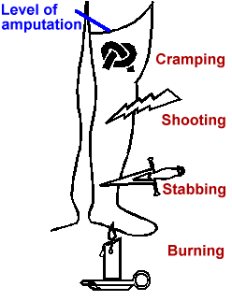
Figure 1. Common descriptions of phantom pain
Phantom limb pain occurs among between 50 and 80 percent of amputees(9,10). The most common descriptions of phantom pain are variants of cramping, burning/tingling, and shocking/shooting/stabbing (Fig. 1). Each amputee tends to report the same one or two descriptions of phantom pain whose locations within the phantom remain consistent over time. A large minority have episodes severe enough to interfere with work, sleep and desired social activities which occur frequently enough to require treatment.
Phantom pain can occur anytime, from just after an amputation to years later. Its occurrence is not related to psychological factors(12), age, sex, location of the amputation, or reason for the amputation (e.g. trauma vs. disease). Different individuals report their phantom pains to be affected by different environmental variables such as changes in humidity and temperature(2,10). As is true with all chronic pain syndromes, stress and fatigue can magnify the sensations but there is absolutely no evidence that any psychological factors cause phantom pain(1,12). Pain from pinched nerves in the back and other sources is referred to the phantom limb as it would be to the original limb.
Recent surface electromyographic studies(8,11) have demonstrated that the major muscles in the residual limb tense up several seconds before the cramping phantom limb pain begins and that these muscles remain tense for much of the duration of the episode. The pattern of tensing is usually shown by an abrupt increase in magnitude of surface electromyogram to about twenty times baseline values. Other studies(6) have demonstrated that burning phantom limb pain is closely associated with reduced blood flow in the residual limb. There is currently no evidence associating shooting/shocking descriptions of phantom pain with specific physiological mechanisms. However, very similar sensations are provoked during ectopic stimulation of nerves from a neuroma.
In the past, the success rate for treatment of phantom pain has been dismal, with only about one percent of treated amputees reporting effective relief lasting for at least a year(9,10). At least forty-three ineffective treatments were in common use until recently(10). They range in invasiveness from lobotomies and major spinal surgery, through surgical revision of the residual limb, psychotherapy, and psychoactive drugs, to transcutaneous electrical stimulation and similar techniques. The only treatments consistently able to ameliorate phantom pain were sympathetic locks and sympathectomies which were useful for burning phantom pain for up to a year.
Current treatments are based on the mechanisms discussed above and have been proven to be more effective(5,7). Cramping phantom pain responds well to treatments which result in preventing the residual limb from tensing up abnormally, while burning phantom pain responds well to treatments which increase blood flow, both in and out of the residual limb. No treatments have been identified as being consistently effective for shocking/shooting descriptions of phantom pain. The diagnostic decision making process for choosing the treatments most likely to be effective for different descriptions of phantom pain has been detailed elsewhere(3).
Biofeedback Treatment
For patients who describe burning/tingling phantom limb pain and have an essentially normal reactive vascular system, a trial of temperature biofeedback may provide relief. We start these patients out with surface electromyographic biofeedback because we find that it is easier to learn and gives trainees the confidence they need when learning to control their limb temperature. If the patient describes cramping/squeezing phantom limb pain, and is able to learn control of the voluntary muscles, a trial of surface electromyographic biofeedback is appropriate. Amputees who give mixed descriptions of phantom pain which include shocking/shooting sensations may have success learning to control other descriptions of phantom pain but the shocking/shooting sensations are likely to remain unchanged. Amputees reporting combined burning and cramping pain are given treatments aimed at controlling both underlying mechanisms.
The specific aim of the treatment is to teach amputees with burning/tingling phantom pain to habitually and unconsciously keep their residual limbs as warm as the intact limb. For amputees with cramping pain, the aim is to teach them to prevent the onset of the types of increases in muscle tension in the residual limb which lead to pain. These aims are approached through several overlapping stages:
- First, subjects are shown the relationship between the residual limb's temperature or muscular activity and the onset and intensity of phantom pain, so they are absolutely convinced of the relationship.
- Next, they are given muscle tension and temperature awareness training very similar to Jacobson's system. They are given tape recorded exercises to play at home at least twice per day. The aim of this phase is to begin increasing their awareness of changes in limb temperature and tension patterns as well as to begin helping them learn to control these parameters.
- After several weeks, the tapes are used only once per day and the patients begin doing the exercise on their own at least once at home and once while out in their normal work environment. This is intended to begin generalizing their awareness of changes in the parameters to their normal environment.
- The week after, subjects begin home training, they participate in weekly or biweekly biofeedback sessions conducted in the clinic. The sessions follow the guidelines detailed in the Association for Applied Psychophysiology and Biofeedback's application standards manual(14).
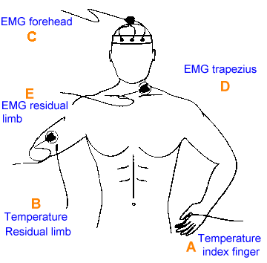
Figure 2. Placement of EMG and temperature sensors
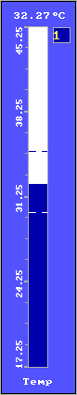  Figure 3.  Bar graph
  - Subjects being taught temperature biofeedback begin by having the dominant index finger instrumented with a single temperature sensor (fig. 2A). If neither hand is present, the toes are used. Skin temperature is fed back to the patient from both a line graph or bar graph display (fig 3, 4) and an auditory signal (illustrations are from Thought Technology's ProComp+/DOS biofeedback system).
  - They continue to receive training for this area until they demonstrate the ability to consistently and reliably raise their finger temperature. We do not normally either have patients work to a preset goal or require the ability to quickly raise, lower, and then raise finger temperature, because achievement of these goals does not seem to relate to symptom control. Instead, we tailor each treatment to the individual's ability to raise temperature.
  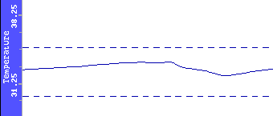
  Figure 4. Line graph
• After control is demonstrated in the finger, the sensor is mounted on the warmest portion of the residual limb (figure 2B) and ability to control temperature of that area is trained. This is a slow process which can take eight sessions or more. The sensor should not be placed near the end of the residual limb as the vascular bed, in that area, is highly abnormal and most subjects have not learned to control limb temperature when the sensor is placed there.
• Subjects who are being taught to recognize and control muscle tension receive a similar program. Their foreheads are insturmented with surface electrodes (figure 2C) and signals are fed back through a light bar or auditory display (figure 5.) Picture of MyoTrac 2 Dual channel EMG system provided by Thought Technology Ltd.)

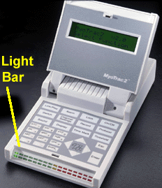
Figure 5. Light bar feedback display
• Instruct the patient to lower the tone and light bar readings. When they can demonstrate the ability to reliably relax the facial muscles, the sensors are moved to the right or left trapezius sites where similar training is performed (figure 2D).
• After control is demonstrated, place the EMG electrode over one of the major muscles of the residual limb (figure 2E) and teach the subject to recognize tension patterns by controlling muscle tension in the limb. This process can take twelve sessions or more.
• Awareness of the residual limb's temperature and/or patterns of muscle tension in the patient's environment is emphasized throughout the training process so that control is eventually achieved while the subject is in the normal environment without the subject having to concentrate on continuously maintaining control.

