Functional Near InfraRed Spectroscopy (fNIRs)

A system of creating functional images by sending bouncing light into the brain and reading the reflections to determine how much oxygenated blood is present

What is a Functional Image?

A functional image is a viewable image created by taking data extracted from the sensors. This typically involves complex algorithms and is based on past repeatable indicators.

From http://www.iscpubs.com/articles/al/a0110fan.pdf
A non-invasive approach to using near infrared light (700-900 nm) to probe through the intact scalp and skull. The main In fact, it is now well-established that near-infrared light penetrates through the intact scalp and skull to illuminate the brain, much like sunlight penetrates through the clouds to illuminate the earth (the similarity between the two cases is that both the skull and the clouds act as stronger light scatterers than light absorbers). The main absorber for near-infrared light in brain tissue is hemoglobin (the oxygen-carrying protein in the blood) whose light absorption properties depend on its level of oxygenation.

The Machine
The optical instrument is a versatile, four-channel tissue spectrometer consisting of two synchronized tissue oximeter units (model 96208) (ISS, Inc., C h a mpaign, IL). The four parallel detection channels consist of four photomultiplier tube (PMT) detectors whose outputs are directed to a four-channel, 16-bit A/D acquisition card. These four independent detection channels are timeshared by 32 laser diodes that are multiplexed at a frequency of 100 Hz. In other words, the laser diodes are turned on and off in rapid succession with an on-time per diode of 10 msec. The average optical power emitted by the laser diodes during the on-time is no more than a few milliWatts.

From http://www.iscpubs.com/articles/al/a0110hos.pdf
Subjects can be examined under more natural conditions such as sitting in a chair, without their motion being severely restricted. Furthermore, the portable, telemetric NIRS system enables activation studies on freely moving subjects. It
is thus expected that NIRS will make functional mapping studies possible in contrast to neuroimaging techniques such as positron emission tomography ( P E T ) and functional magnetic resonance imaging (fMRI).

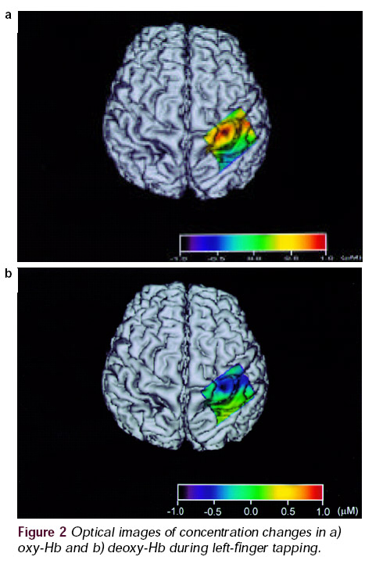

Drexel University is doing a lot of work on combining fNIR with EEG
http://www.biomed.drexel.edu/bitlab/Projects/projects.html

Where the heck is this “Near Infrared” in the electromagnetic spectrum
