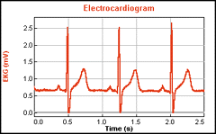
EKG Sensor

The EKG Sensor measures electrical signals produced by the heart. It uses three disposable electrodes. An EKG graph is displayed, demonstrating to students the contraction and repolarization of the heart's chambers.
How is an EKG Done?
- Ten sensors are attached to your arms, legs, and chest (around the heart area).
- This is indicated with a square and circle symbol on the following diagram:
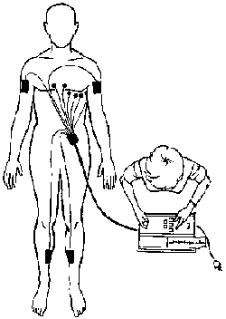
- These sensors "listen" to your heartbeat and make a wave pattern on graph paper.
- Electrical impulses associated with heart contraction and relaxation are recorded.
- From the pattern on your EKG tracing, your doctor can check on how your heart is doing
The EKG sensor measures cardiac waveforms generated by electrical activity of the heart muscle. The cyclical contraction and relaxation of the atria and ventricles involves polarization and depolarization of heart muscle fibers. This creates an electrical current that moves through the body, and which can be measured by electrodes attached to the skin.
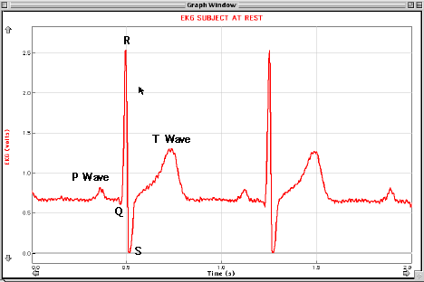
The subject should be stationary when making the measurements, but interesting comparative data may be collected before and after exercise. Other interesting investigations involve placing the electrodes at different places on the body to determine the axis of the heart, and studying the change in the waveforms before and after the ingestion of mild stimulants (e.g. caffeinated coffee or cola).
Interesting Application:
Emergency medics will soon know a patient’s condition with just a touch
7 May 2003–A new sensor technology may fit like a glove–literally–for medics who need to take fast, accurate readings of vital signs when assessing the wounded. The heart of the system, known as MIDDAS (Mobile Integrated Diagnostic and Data Analysis System), is a glove with built-in sensors that allow medics to perform an EKG (electrocardiogram) measuring pulse rate, core body temperature, blood-oxygen level, heart rate variability, and even blood pressure. The system also makes use of wireless communications: readings from the glove wired to a PDA can be beamed to a laptop or a computer at a hospital, allowing medics to easily store and retrieve data.
Developed by Titan Corp. (San Diego, Calif.), primarily a U.S. Department of Defense contractor, MIDDAS could help medics sort through the chaotic process of triage when there are a number of casualties and only limited resources. Medics must assess the wounded to determine which patients need immediate care.
Designers tout the glove as a one-touch diagnostic tool to speed up the triage process. For example, blood pressure measurements, which in a doctor’s office require encircling a limb with an inflatable cuff, can be achieved in under eight seconds using the MIDDAS glove. EKG sensors embedded in the pinky and thumb of the glove combined with an optical sensor embedded in the index finger allow medics, by touching the patient’s upper chest and neck, to measure the time-delay from when the heart contracts to when the pulse arrives in the carotid artery in the neck. An algorithm that takes into account age, sex, and weight of the patient can then estimate blood pressure.
Mark I. Darrah, Titan’s advanced concepts director who is based in Rancho Cucamonga, Calif., acknowledged that several other companies have had the idea of designing a sensor-laden glove to help doctors, but noted that MIDDAS combines sensor technology with a communications network to send and store information.
With MIDDAS, data gets wired from the sensors through a signal processor attached to the back of a PDA worn by the medic. Using the Hewlett-Packard Compaq iPaq handheld. which has a specially written graphical user interface that includes graphics and color-coded alerts, medics can evaluate a patient’s condition.
The sensor readings also get beamed from the iPaq to a ruggedized laptop (currently from the Panasonic Toughbook series) in the medic’s vehicle via a wireless local-area network using the IEEE 802.11b standard. The laptop would allow a single user to monitor up to 200 patients, and the computer also can send out alerts to medics should a patient’s condition worsen. For military applications, engineers have plans to add real-time data encryption software and frequency hopping functionality to the system. Darrah said the company also plans to use Bluetooth technology to link the glove wirelessly to the PDA in civilian applications.
The system also includes a set of sensors that stay with the patient to continue monitoring vital signs. Darrah says a dedicated computer back at a hospital would not only store data sent from the laptop using cellphone or satellite technology, but could also allow for two-way connectivity, allowing medics quick access to a patient’s medical history.
Another advantage is that the system has been designed to work in environments where line-of-sight systems might have trouble, such as a crumbling building. Engineers have developed an effective "breadcrumb" approach, using a peer-to-peer protocol for the iPaqs that allows them to serve as "basically an inexpensive, highly effective relay," according to Darrah.

Military origins
The U.S. military is looking at MIDDAS as one of several projects to advance battlefield medicine. William R. Rowley, a retired Navy rear admiral, notes that MIDDAS’s prime purpose, triage, is critical to health care in military operations. "There are some people…with injuries so severe that no matter what you do, you can’t save them," he says. "Then there is another group, if you devote enough time and resources you could save them…but you can’t afford to." Battlefield medicine, he adds, is about looking for "the greater good for the greater number."
While MIDDAS has been five years in development and the U.S. government has poured in more than US $5.5 million in funding, it remains in the proof-of-concept stage. Field-testing is scheduled for this summer, according to a spokesperson for the Navy Health Research Center (San Diego, Calif.), which has been managing the project.
MIDDAS, which also drew funding from the U.S. Army, was too late for use during Gulf War II. The technology, therefore, could see its first use riding along with big-city emergency medical services. Clark County, which includes Las Vegas, Nev., has agreed to be the municipality to field-test the technology, and Darrah says that Philadelphia also plans to seek funding to field-test the glove as well. Says Clark County fire protection engineer Richard A. Brenner: "On a mass casualty event, for me to do a triage on somebody…you’re talking at least five minutes. With this I can do it in under a minute."

