EEG Info

Alternative names:
Electroencephalogram; Brain wave test

Theory:
Brain cells communicate by producing tiny electrical impulses. In an EEG, electrodes are placed on the scalp over multiple areas of the brain to detect and record patterns of electrical activity and check for abnormalities.
EEG cannot be used to "read the mind," measure intelligence, or diagnose mental illness.
From http://www.nlm.nih.gov/medlineplus/ency/article/003931.htm
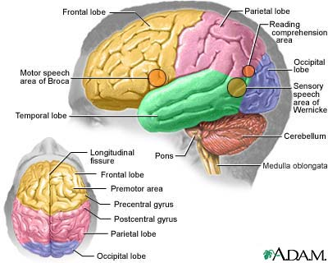

Data:
Signal recorded from surface of the scalp
Strength: 1-20 microvolts
Bandwidth: 0-35Hz

Extremely susceptible to interference from ambient electrical fields, subject movements and eye-blinks.

IEEE paper talks about pre-processing the EEG signal to clean up interference from such ambient electrical fields:
Pre-processing EEG for Direct Human-System Interface, a paper selected for presentation at IEEE Conference on Intelligence in Neural and Biological Systems at Washington,USA on Nov. 4, 1996

EEG activity can be broken down into 4 distinct frequency bands:
Beta activity > 13 Hz
Alpha activity 8 Hz-13 Hz
Theta activity 4 Hz-7 Hz
Delta activity < 4 Hz
Beta activity is a normal activity present when the eyes are open or closed. It tends to be seen in the channels recorded from the centre or front of the head. Some drugs will increase the amount of beta activity in the EEG.
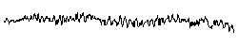
Beta activity
Alpha activity is also a normal activity when present in waking adults. It is mainly seen in the channels recorded from the back of the head. It is fairly symmetrical and has an amplitude of 40 µV to 100 µV. It is only seen when the eyes are closed and should disappear or reduce in amplitude when the eyes are open.
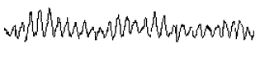
Alpha activity
Theta activity can be classed as both a normal and abnormal activity depending on the age and state of the patient. In adults it is normal if the patient is drowsy. However it can also indicate brain dysfunction if it is seen in a patient who is alert and awake. In younger patients, theta activity may be the main activity seen in channels recorded from the back and central areas of the head.
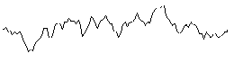
Theta activity
Delta activity is only normal in an adult patient if they are in a moderate to deep sleep. If it is seen at any other time it would indicate brain dysfunction.
Abnormal activity may be seen in all or some channels depending on the underlying brain problem.
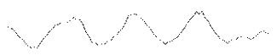
Delta activity
There are a number of other waveforms which tend to be a little more specific to certain conditions. For example spike and wave activity indicates a seizure disorder and may be seen in the EEG even if the patient is not having an epileptic seizure. Other epileptic conditions may be diagnosed if spikes or sharp waves are seen.
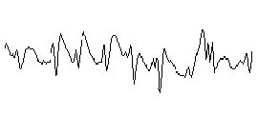
Spike and wave activity
Triphasic waves are sometimes seen if the patient has severe liver or kidney disease that is affecting brain function.
These are just brief descriptions of some of the simpler waveforms that may be seen in any one EEG recording. Combinations of any of the above patterns are possible which can make interpretation of the record difficult. Abnormal activity is not always specific to any condition and may suggest a few different diagnoses.
Analysis:
Power Spectrum Analysis. A Fast Fourier Transform (FFT) is performed on sections of EEG data to determine the power content of the four main frequency bands. The resulting waveforms can be displayed as a brain map which will show the scalp distribution of the power within each frequency band.

The amplitude of the different waveforms at a single point can also be displayed in a similar format.

This type of display provides a more objective analysis of the EEG activity compared to a subjective visual analysis by a physician.

[from Kyle: this FFT would actually be very easy and fun to implement should we choose to play around with brain states and EEG!]

Applications:
-diagnosing and treating disorders
-anxiety, depression, ADD, seizures, etc
[From Kyle: Apparently, learning to control your brain waves is just like learning to control any other physical part of your body, for instance, a finger or an arm. With your physical body, you have constant “biofeedback” in the sense that you can SEE your body moving. The EEG provides a similar visual representation of the brain’s activity, which a person can use to visually evaluate and reinforce their actions. After the brain “learns” to control itself, it no longer requires feedback, just as you can move your arms and legs reliably without looking at them!]

Media:
Really cool PBS spot on things you can do with EEG – like drive a boat. The military is very interested in it too, interestingly:
http://pbs-saf.virage.com/cgi-bin/visearch?user=pbs-saf&template=play220asf.html&query=%2A&squery=%2BClipID%3A6+%2BVideoAsset%3Apbssaf1107&inputField=%20&entire=No&ccstart=2797097&ccend=3307328&videoID=pbssaf1107

Interview with some dude:
http://members.aol.com/williamcscott/jimrobbinskpfk.ram

