Who’s who in the Future Force Warrior Project

Organization: Clemson University
Location: Clemson, South Carolina
Area of expertise/contribution: Arousal Index
People: Eric Muth
Notes: experience creating psychology experiments

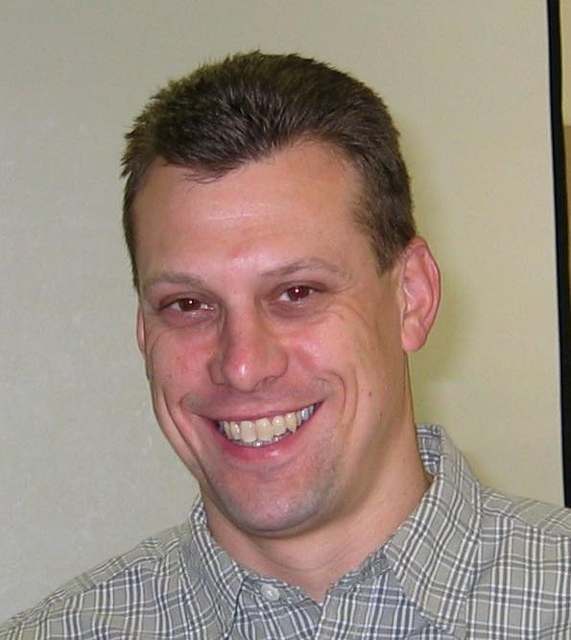
Eric Muth, PhD
muth@clemson.edu
864.656.6741
FAX 864.656.0358

Organization: Laboratory for Intelligent Imaging and Neural Computing (LIINC)
Location: Columbia University, New York, New York
Area of expertise/contribution: P300 Gauge
People: Lucas Parra (City College of New York), Paul Sajda (Columbia), Adam Gerson (Columbia)
Notes:

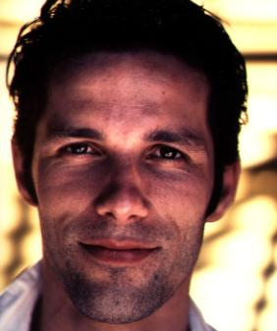  Lucas Parra, PhD  parra@ccny.cuny.edu | 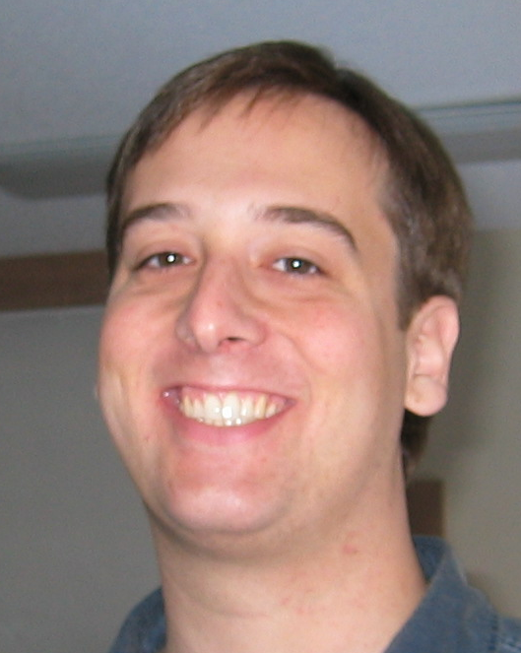  Adam Gerson  adg71@columbia.edu
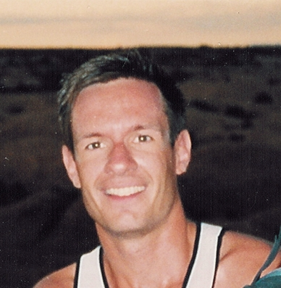
Paul Sajda, PhD
Ps629@columbia.edu
212.854.5279
FAX 212.854.8725

Organization: Institute for Human Machine Cognition (IHMC)
Location: University of West Florida, Pensacola, Florida
Area of expertise/contribution: Sensor architecture and combined stress gauge
People/Pics: Anil Raj (others who specialize in the architecture software)
Notes:

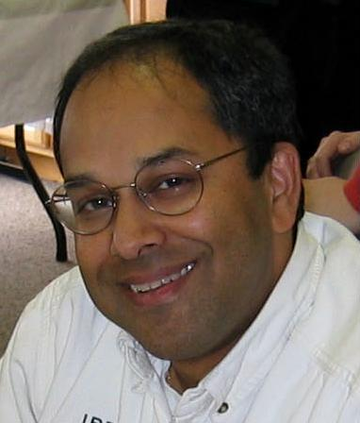
Anil Raj
araj@ai.uwf.edu

Organization: Human Bionics
Location: Virginia
Area of expertise/contribution: Executive Load Index, mobile EEG sensor
People: Don DuRousseau
Notes: Will train us on the EEG when he visits

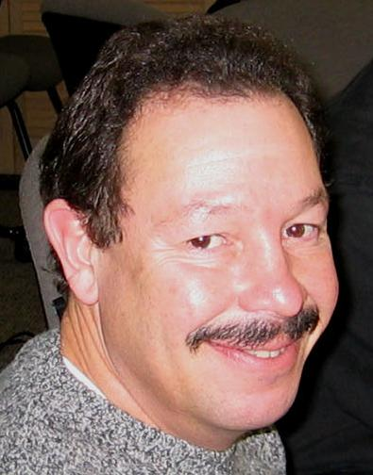
Don DuRousseau
don@humanbionics.com

Organization: Honeywell Technology Center
Location: Minneapolis, Minnesota
Area of expertise/contribution: Engagement Index, Quake3 environment
People: Trish Ververs (not in MN) Steven Whitlow, Michael Dorneich, Jeff Rye, Jim Carciofini
Notes: experience integrating with the sensor architecture

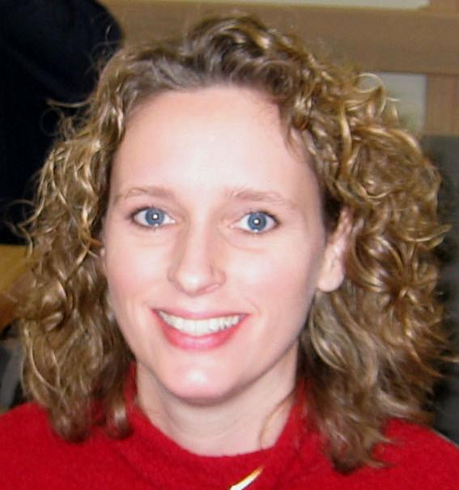  Trish Ververs  trish.ververs@honeywell.com | 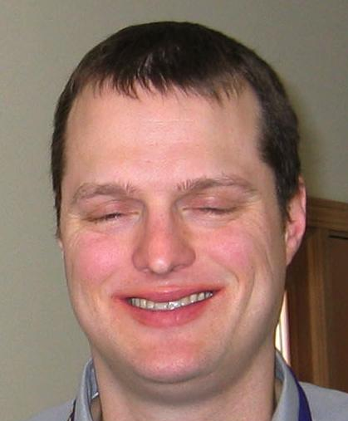  Steven Whitlow  stephen.whitlow@honeywell.com
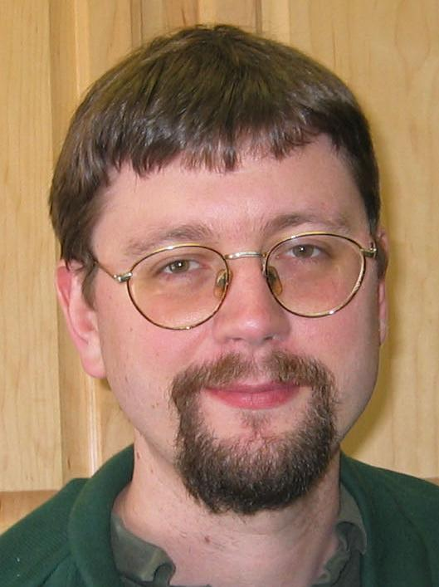  Michael Dorneich | 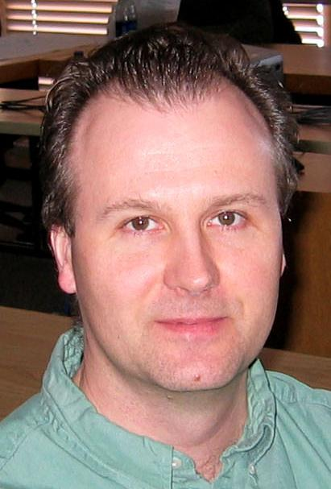  Jim Carciofini  jim.carciofini@honeywell.com  612.951.7306  Integrated sensor architecture into Quake3
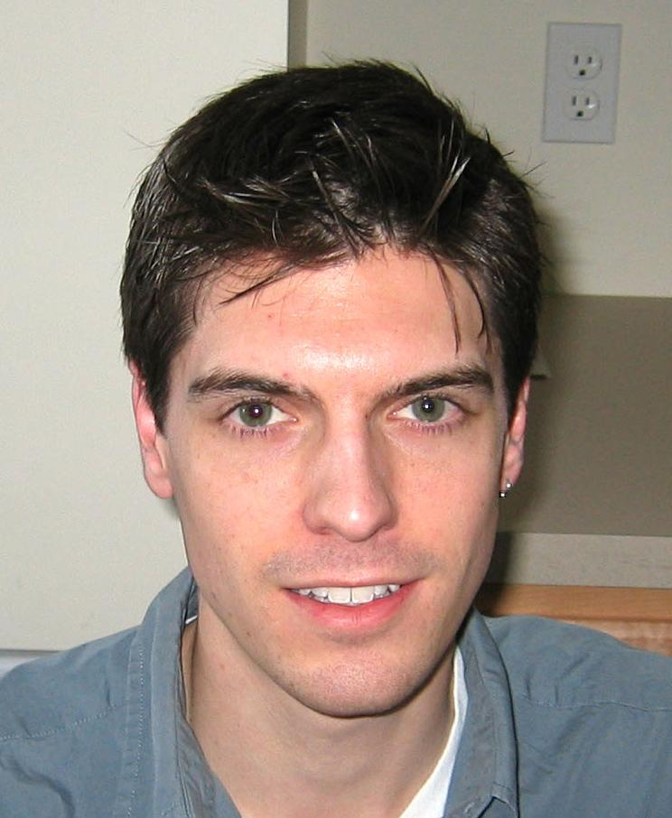
Jeff Rye
jeff.rye@honeywell.com
612.951.7219
FAX 612.951.7438
Integrated sensor architecture into Quake3

Organization: Proffitt Perception Lab
Location: University of Virginia, Charlottesville, Virginia
Area of expertise/contribution: Attention-based psych experiments, fNIR sensor
People: Denny Proffitt, Ben Darling
Notes:

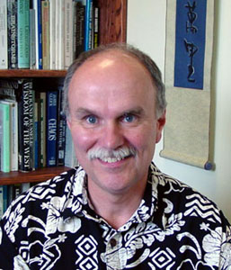  Denny Proffitt, PhD  drp@virginia.edu  434.924.0655 | 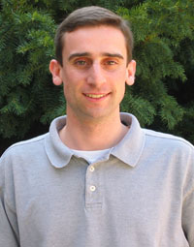  Ben Darling  bad3x@virginia.edu

Organization: Oregon Health & Science University
Location: Beaverton, Oregon
Area of expertise/contribution: Experimental psychology
People: Misha Pavel
Notes: the experimental psych guru on the project. Was heavily consulted at the Phase 2B kickoff meeting.

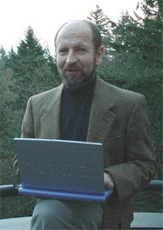
Misha Pavel, PhD
pavelm@ohsu.edu
503.748.1155
FAX 503.748.7038

