CONFIDENTIAL

Digital Music Distribution Project

Concept Description
January 20, 2003

The Entertainment Technology Center



Jon-Paul Dumont
Yusei Horiuchi
Bob Rost
Gabe Sabourin

Tina Blaine, Faculty Advisor

CONFIDENTIAL

Introduction
The research objective of this project is to determine feasibility of a new digital music delivery system. This system should allow customers
without internet access or computers to have as rich an experience as those with such resources, without having to compromise quality. Also important to the system is copy protection and piracy prevention, to protect the interests of the musical artists involved.

Available market data
The market for personal digital audio players jumped to 1.7 million in 2002, up 56 percent over 2001, and is expected to rise another 26 percent to 2.1 million units for 2003.

Although it is hard to gauge the number of people using file-swapping services, their popularity is strong. During one week in December there was almost four million downloads of programs like Kazaa and Morpheus from CNET’s Download.com. From anecdotal evidence and various news articles, there is a strong belief that a sizable percentage of these users would pay for MP3s if that service were easy and secure.

More research is needed to determine the market for and penetration of personal digital audio players in urban areas such as Harlem.

Summary of current technology

In Japan, a kiosk called the G-Book E-Tower is available for use in convenience stores that provides customers a variety of services. It allows them to insert Memory Stick or SD memory and purchase songs one at a time, as well as download car navigation maps and other related services.
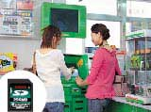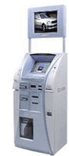
The Japanese E-Tower

In America, MP3 players are becoming rather inexpensive and very popular among some demographics. Many of the popular MP3 players, however, do not allow anyone to copy music from the device to the computer, as a measure of music piracy prevention.

Some legal online music websites exist, which allow people to download either free music from independent artists, or commercial music for a fee. Universal Music Group, for example, allows customers to download single tracks for a fee in the range of $1 to $1.49. It allows the customers to listen to the music on multiple computers, burn it to CD, etc., but it tracks where each song is played, so that piracy can be tracked. Other services allow customers to pay a monthly fee for unlimited downloading of the catalog.
Using the kiosk
The Digiwaxx kiosk will be the place where customers can go to purchase, download, and manage their music collection. A touch screen interface will allow customers to interact with the kiosk and purchase music.

Interface flow
The basic interface would work similar to the chart below:

Purchasing a song
When a customer purchases a song, the kiosk contacts the main Digiwaxx servers and alerts them that the customer has purchased the song. The kiosk then downloads a copy of the song if it does not already contain a cached copy, and it uploads the music to the customer’s music device. Pricing could be static, such as $1 a song, or vary based on the number of songs bought, the media format bought or for special promotions.

Kiosk as a personal device
If the customer has run out of space on his device, he can opt to get the song later, or he can choose to remove an existing song from the device to create enough free space for the new song. Later, if he decides to get the deleted song again, the system will already have a record of the customer’s purchase and authorize him to download it again, without having to pay twice for the same music. This allows the customer to use the kiosk in place of a home computer.

Kiosk networking
In our software system design, music in the Digiwaxx system will be stored on master servers, perhaps located at Digiwaxx headquarters in New York. The kiosks, located in music stores connected to the internet, will contact these central servers for featured content updates, and to retrieve customers’ purchased songs. The central servers will also keep record of customers’ purchased songs, to allow them to have records of their transactions, no matter which kiosk they visit.

Network traffic can be reduced significantly if the kiosks keep local cached copies of popular media (determined per kiosk by time-diminishing popularity queue), and further reduced if the servers keep track of the most recent kiosk a customer has visited. This will ensure that for most transactions, the kiosk will not need to download the media or the customer’s purchase information, thus reducing the load on the main servers and positively enhancing the customer’s experience. Additionally, this will allow the system to still have a degree of functionality in the event that the kiosk loses its network connection to the central servers.

Customer identification
When dealing with sensitive information such as financial transactions, customers need to know that the transaction is a safe one. For this reason, kiosks would need a method by which customers can identify themselves as the same customer who bought a particular hit last week and would like to purchase a new song this week. Once a customer has been identified by the system, he has full access to his collection of purchased music. Several methods of identification can be used. The ideal solution may be a combination of some of the below methods.

Biometric Data. Each person on the planet has a unique fingerprint and retinal image. Fingerprint scanners and eye scanners are becoming more common as the technology improves, and they may we worth considering for authentication, though some research is still necessary to determine their reliability. Such a device could be used by a kiosk to uniquely identify each customer for authentication.

Phone Number. A single phone number is generally shared by no more than about five or six people. Furthermore, most people have no trouble remembering their own phone number. Combining this with a four- or five-digit PIN number could provide a fairly high level of security, which can be heightened further by a randomized keypad seen only by the customer logging in to the system. The primary security concern in this case is that someone else who knows your phone number could possibly guess your PIN and use your account, and some customers may even forget their own PIN numbers.

DigiCard. A customer making his first purchase could receive a DigiCard, which the system uses to identify him the next time he uses a kiosk. The card would contain a unique identifier that the system can use as login authentication. The main drawback in this case is stolen or lost cards. Combining the card will prevent others from using the card, but it still does not solve the issue of a lost card.

Credit Card. A credit card is commonly used for identification on the internet and in retail settings, and most credit card owners generally carry their cards. However, two main problems exist. First, someone with multiple credit cards may not always have the same card with him at all times. The second, more important, problem is that not all people have credit cards. Teenagers make up a very large portion of a music store customer base, but not all teenagers carry credit cards.

Username and Password. A username and password combination is a common authentication method used on the internet. An onscreen keyboard can be used for entering such information to the kiosk. It can be effective, but most people have poor password practices. Choosing a password such as a pet’s name or a common word invites unwanted access to an account, but a proper secure password is hard to remember. Further, people looking over a customer’s shoulder may be able to see the username or password being typed in.

Alternative setup – the dumb machine
A cheaper alternative to the kiosk identifying the customer would keep them anonymous. It would not matter who was at the machine as long as they had a device to download their song to.
Piracy prevention

For a flexible kiosk design, codecs such as MP3, WMA, and ATRAC should be supported, but it would not be easy to prevent piracy since customers couls still upload them to computers and trade them online.

A copy protection scheme that seems to be gaining popularity is digital rights management, which in many cases is simply a flag that indicates whether or not a piece of media allows copying. This method is fairly simple and works in certain situations, but it can be fairly easy to defeat, and it may not be possible for some popular formats, such as MP3 and CD.

More research is needed to determine how feasibly anti-piracy would be.

Paying for the music
There are several options available for the customer to pay for music.

Credit card
This is the most obvious solution. A credit card machine would be built into the kiosk. The major downside is that it prevents customers without credit cards from using the machine.

Cash vending
This would be ideal for the small amounts of money that will be exchanged per song. The main problem with this is security costs, in that each kiosk would have to be emptied and refilled frequently, similar to a vending machine.

Digiwaxx card
This would be a custom printed card with a magnetic strip or a serial number, similar to gift cards. Customers can purchase the cards in pre-set quantities. This would be an alternative for customers without credit cards if the kiosk did not have cash vending.

Store register
The kiosk would print a receipt after use that the customer would take to the store register to pay. This would require an element of trust on the store’s part.

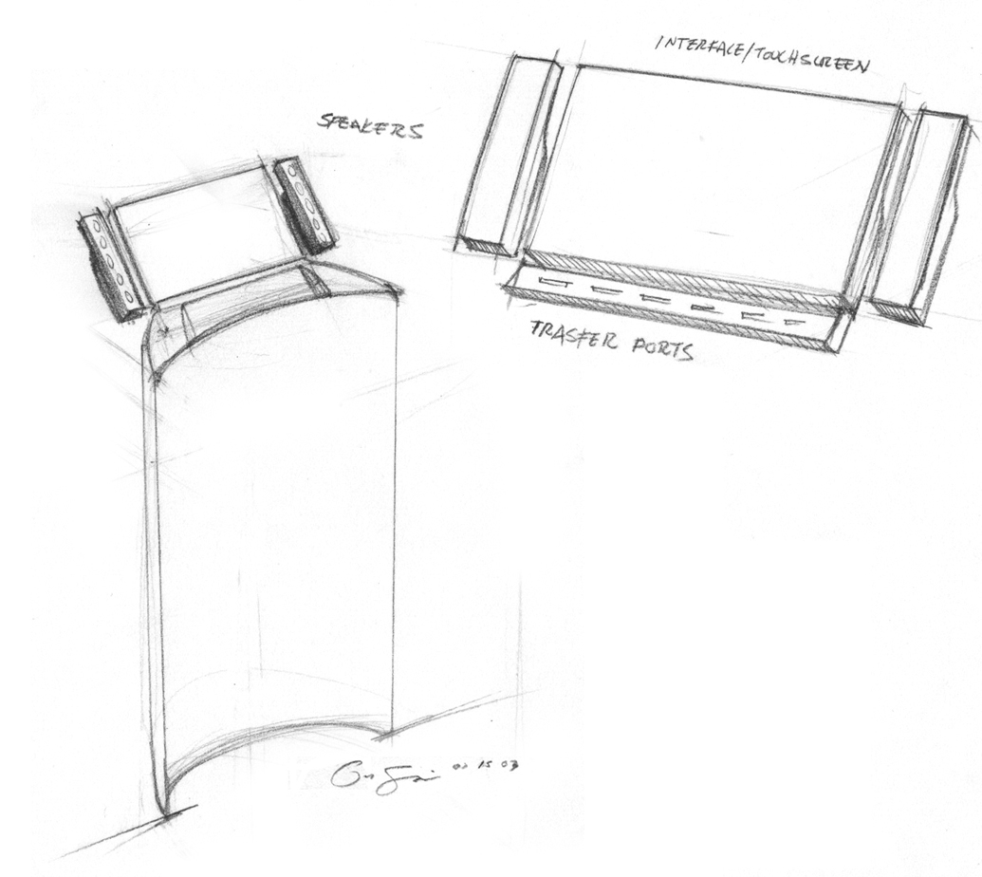
Concept: Flexible Digiwaxx Kiosk
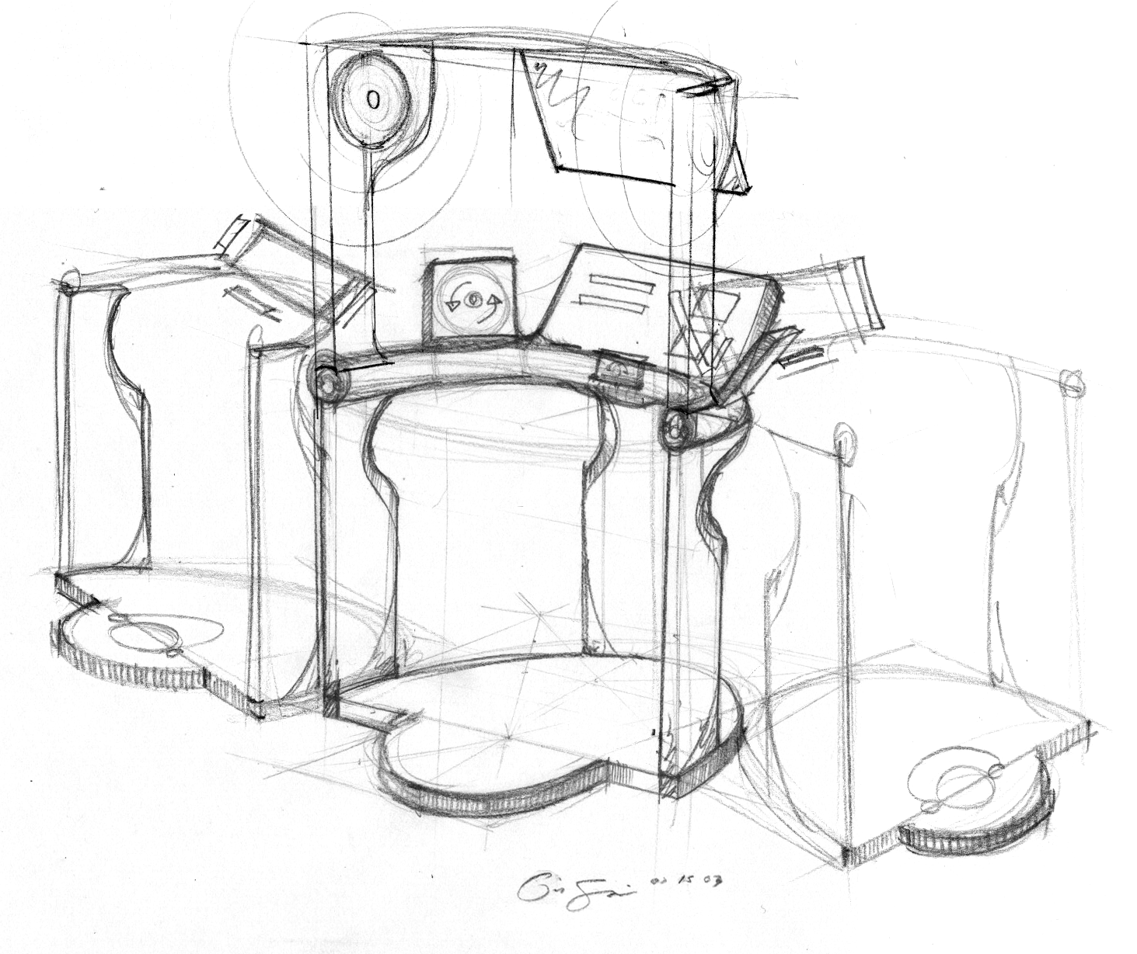
This is stand-alone kiosk solution that would allow a customer to walk up to the machine, sort through available music and purchase songs in a variety of digital formats. It would be flexible in that it could support multiple audio formats, including MP3, Windows Media, or burn a custom CD. It could also be scalable to support multiple hardware platforms, including Digital MP3 players, CD Players, PDAs, external memory cards and possibly cellular phones.

Description of experience
A customer walks up to the machine and plugs-in his MP3 player*. After looking through the ten most downloaded songs he finds the song he is looking for. He puts on the attached headphones to listen to a 20 second sample. He decides to buy it, swipes his credit card, creates a user account and downloads the MP3 to his player.

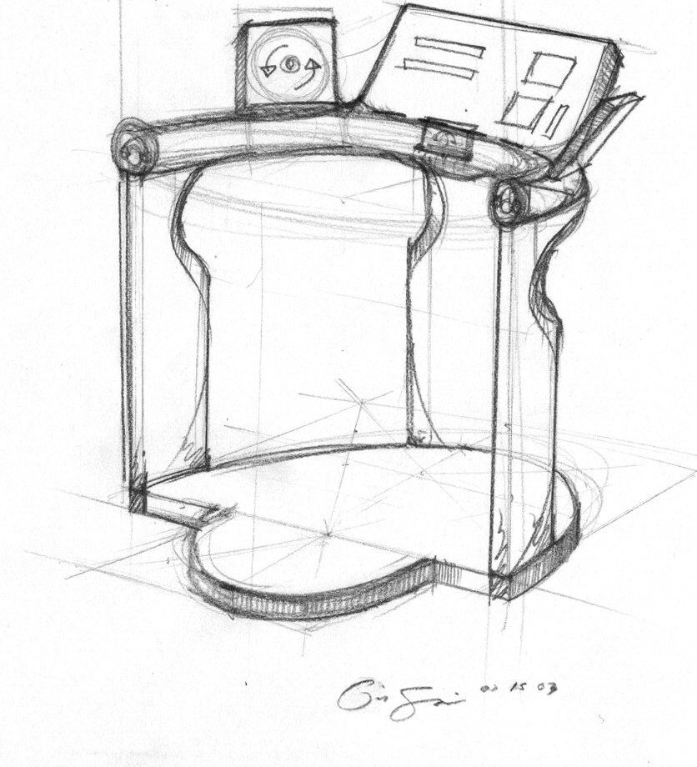
(*i.e. Rio, I-Pod, Nomad, etc.)
Hardware required
Touchscreen, speakers or headphones, computer, internet connection, cradles or connectors for various popular music devices.

Software issues
Need to support many different file formats and device connections.

Piracy risk
High, due to the many open formats that would be supported.

Prototyping timeframe
This is the basic model for the kiosk and would possible to prototype in seven weeks because all the audio formats and hardware connections already exist.

Alternate/future configurations
An initial prototype would only support MP3 players through a USB connection. It could built upon by adding ports for Firewire, Infrared, Cell phones, PDAs or email connectivity. It would also be possible to add additional file formats.

